Day 4 GPUs and Cooling System
1:- Open your own laptop or desktop (or use an online PC hardware simulator if you don't have access to a real system) and identify the GPU model installed. Write down the GPU's brand, model number, and whether it is integrated or dedicated.
What is a GPU?
GPU (Graphics Processing Unit) is a computer component that processes and renders images, videos, graphics, and visual effects. It helps display content smoothly on the monitor and is important for tasks such as gaming, video editing, and 3D applications.
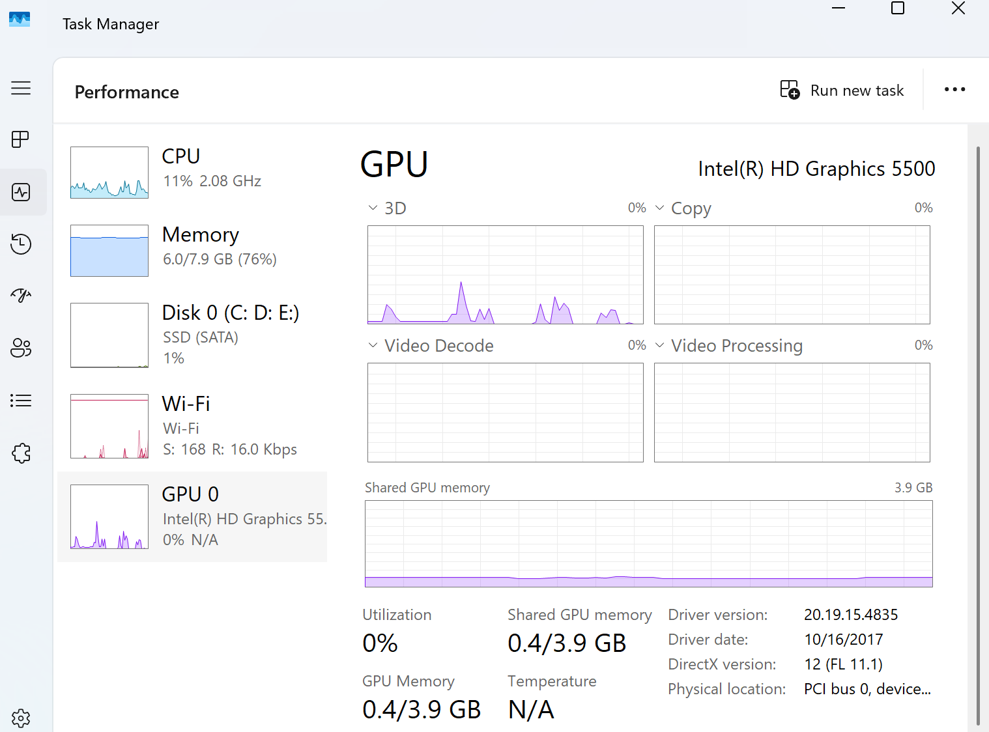

GPU Information
- GPU Brand: Intel
- GPU Model Number: Intel HD Graphics 5500
- GPU Type: Integrated GPU

2:-Take a clear photo or screenshot of the cooling system (fan, heatsink, or liquid cooling setup) inside your PC or from a PC hardware simulator. Label the main cooling components and briefly describe their function.
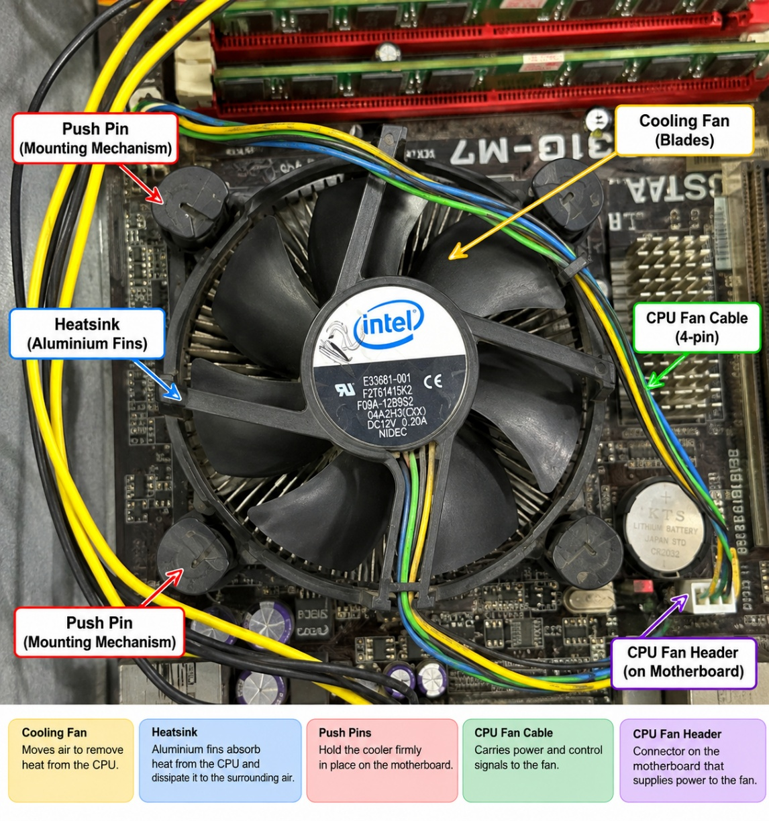

3:- Create a comparison table listing at least 3 differences between air cooling and liquid cooling systems for GPUs, including factors like cost, efficiency, and maintenance.
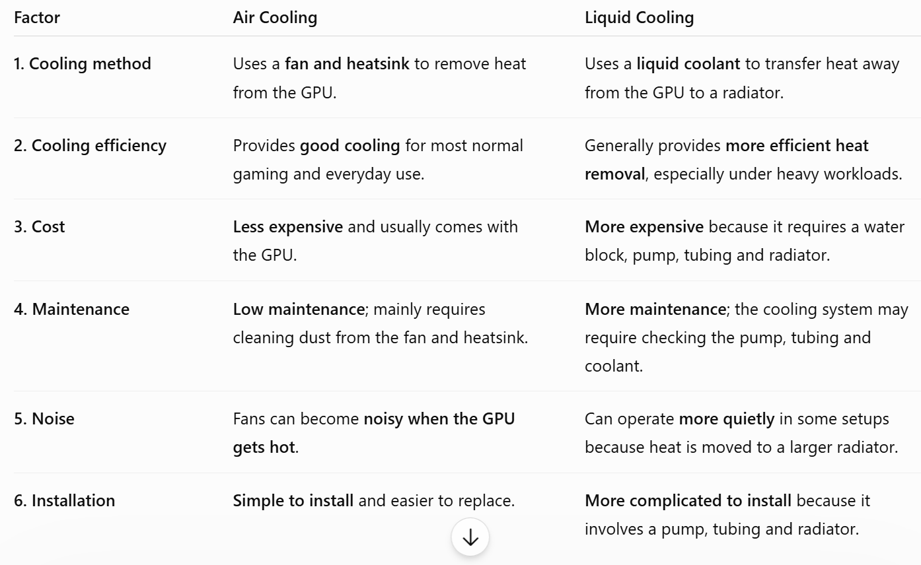

4.Imagine you are building a gaming PC for streaming IPL matches and playing graphics-heavy games. Choose between air cooling and liquid cooling for your GPU, and justify your choice in 3-4 sentences based on your research.
I would choose liquid cooling for the GPU in a gaming PC used for streaming IPL matches and playing graphics-heavy games. Liquid cooling can provide efficient heat transfer and help maintain lower temperatures during long, demanding gaming sessions. It can also reduce the need for high fan speeds, which may help reduce noise. Although it is more expensive and more complex to install than air cooling, it is suitable for a high-performance system with sustained workloads.

